Sirena SUPER 30 Program

VOLUME 1

ROBOT MOTION

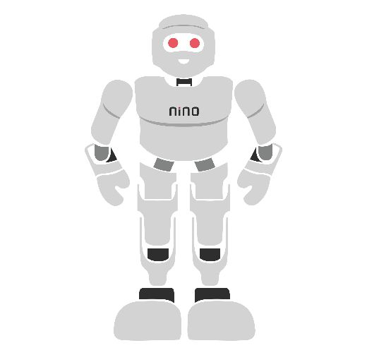

Module Overview
This module builds a complete, practical foundation in robotic motion and mechanical design. We begin by understanding how robots perceive space through coordinate systems, defining Position and Orientation (Pose). We then progress to Velocity and Acceleration, learning how to plan smooth, safe motion profiles for motors and joints. The core of the module covers Basic Kinematics—the mathematics of how joint angles translate to end-effector position (Forward Kinematics) and how to calculate the required joint angles to reach a target (Inverse Kinematics). Finally, we explore Robot Mechanisms, including gears, linkages, and mobile bases like the differential drive.
Every topic is taught with a mix of theory, mathematical examples, and hands-on simulation labs. Learners will use Python/MATLAB to visualize motion and calculate kinematics, bridging the gap between abstract math and real-world robot behavior. Taught end-to-end, the full set of topics is designed to fill approximately 40–45 hours of instruction and practice.
# | Topic | Hands-on Focus
1 | Position, Frames of Reference & Pose | Lab: Visualizing 2D/3D coordinate frames
2 | Velocity, Acceleration & Motion Profiles | Lab: Generating trapezoidal velocity profiles
3 | Basic Kinematics (Forward & Inverse) | Lab: 2-DOF planar arm kinematics solver
4 | Robot Mechanisms & Actuators | Lab: Differential drive and gear ratio analysis
5 | Module Project: Robot Motion Simulator | Lab: Integrate, simulate, and document
Learning Outcomes
By the end of this module, learners will be able to:
- Define position, orientation, and pose in 2D and 3D space using coordinate frames.
- Calculate linear and angular velocity and acceleration, and design smooth trapezoidal motion profiles.
- Derive and solve Forward Kinematics (FK) for simple robotic arms using trigonometry and transformation matrices.
- Solve Inverse Kinematics (IK) for a 2-DOF planar robot using geometric and algebraic methods.
- Identify and calculate the mechanical advantage of gears, belts, and linkages.
- Model the kinematics of a differential drive mobile robot.
- Use Python or MATLAB to simulate robot motion and verify mathematical models.
- Diagnose common errors in robot motion planning and mechanical design.
Tools Required
Item | Purpose
PC with Python (Anaconda) or MATLAB | Mathematical computation and plotting
Jupyter Notebook or MATLAB Live Editor | Interactive coding and visualization
Matplotlib / NumPy libraries | Plotting trajectories and motion profiles
Webots or Gazebo Simulator (Optional) | 3D visualization of robot mechanisms
Scientific Calculator | Manual kinematics and trigonometry calculations

1. Position, Frames of Reference and Pose
1.1 What is Robot Motion?
When we talk about a robot moving, we are not just talking about its motors spinning. We are talking about changing its position and orientation in the physical world over time. To a robot, the world is a mathematical grid. Before a robot can move from point A to point B, it must know exactly where point A and point B are, and how it is currently facing. This requires a solid understanding of coordinate systems.
1.2 Coordinate Systems and Frames of Reference
Imagine you are giving directions to a friend. If you say "move 5 meters forward," your friend will ask, "Forward from where? And facing which direction?" In robotics, we solve this by defining a Frame of Reference.
A coordinate frame consists of an origin (the zero point, 0,0,0) and a set of axes (X, Y, and Z).
- X-axis: Usually points "forward" or "right".
- Y-axis: Usually points "left" or "up".
- Z-axis: Points "up" (following the Right-Hand Rule).
The Right-Hand Rule: To determine the positive direction of rotation or the Z-axis, point your right thumb along the positive Z-axis. Your fingers curl in the direction of positive rotation (from X to Y).
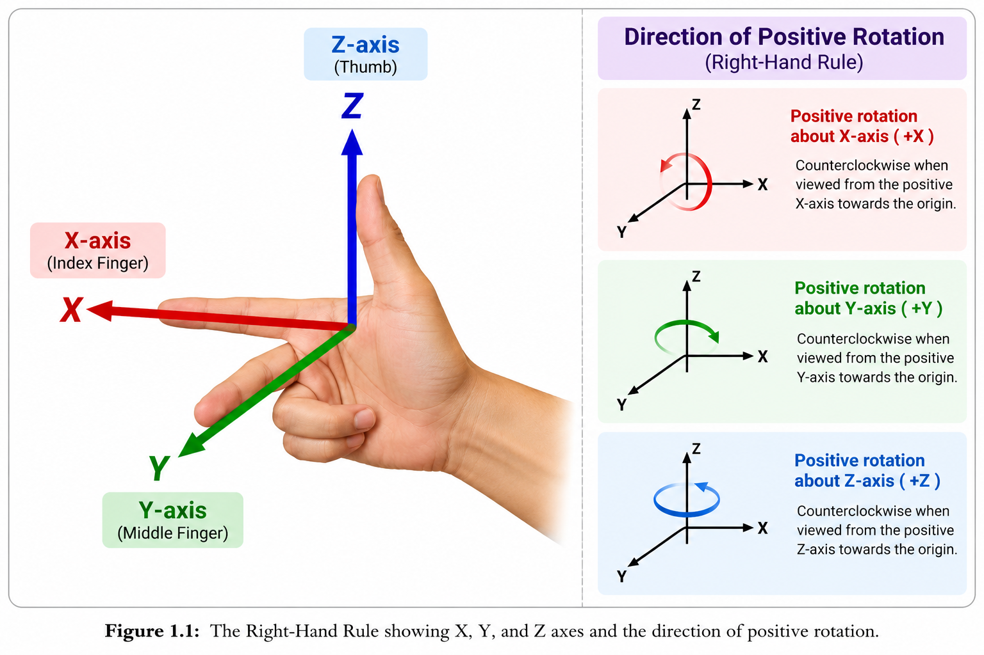
Every robot has a Base Frame (usually fixed to the floor or the robot's base) and a Tool Frame or End-Effector Frame (attached to the robot's gripper or hand). Motion is simply the calculation of the relationship between these frames.
1.3 Position and Orientation (Pose)
To completely describe where a rigid body (like a robot link) is in space, we need two things:
- Position: Where is the center of the object? (Coordinates: x, y, z).
- Orientation: How is the object rotated? (Angles: Roll, Pitch, Yaw).
Together, Position + Orientation = Pose.
2D Pose (Planar Motion)
In a 2D plane (like a mobile robot moving on a flat floor), we only need three numbers to define its pose:
- x: Distance along the horizontal axis.
- y: Distance along the vertical axis.
- θ (theta): The angle of rotation around the Z-axis (heading).

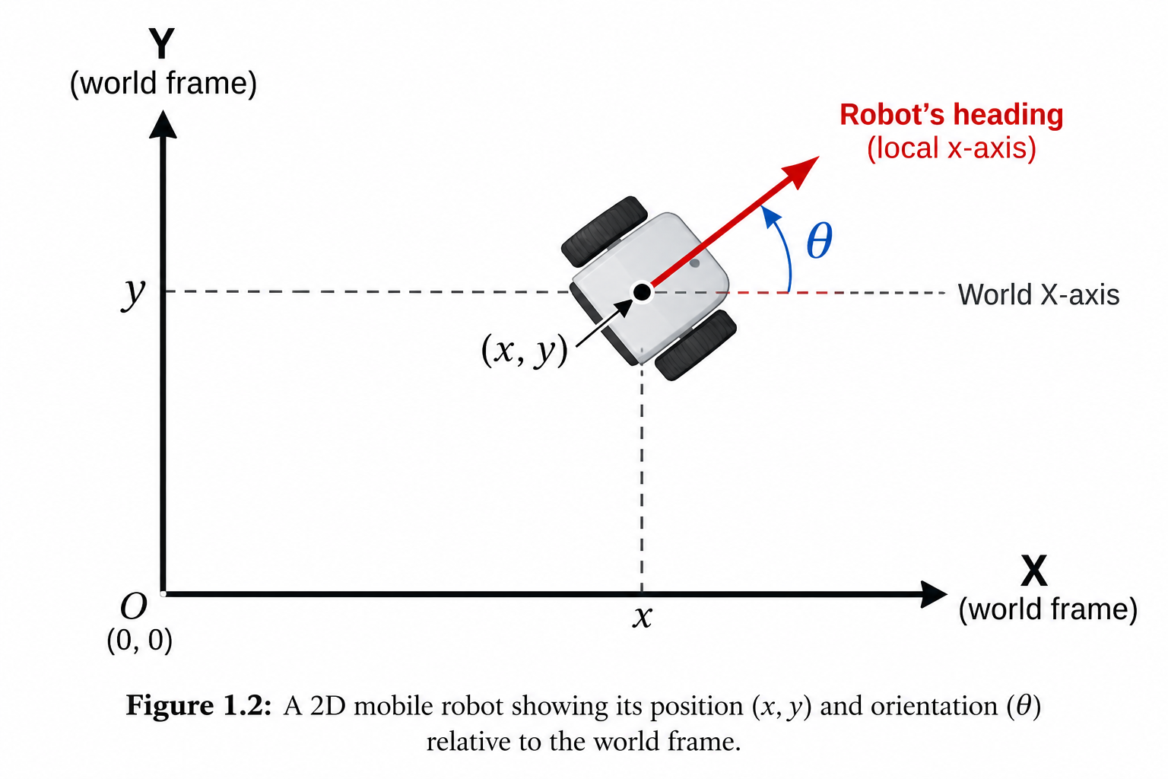
3D Pose (Spatial Motion)
In 3D space, we need six numbers (6 Degrees of Freedom):
- Position: x, y, z
- Orientation: Roll (rotation around X), Pitch (rotation around Y), Yaw (rotation around Z).
1.4 Common Mistakes to Avoid
- Mixing up Degrees and Radians: Trigonometric functions in Python/MATLAB (like sin(), cos()) use radians, not degrees. Always convert: Radians = Degrees * (π / 180).
- Ignoring the Frame of Reference: A position of (5, 0, 0) means nothing unless you specify which frame it is measured from.
- Left-Hand vs. Right-Hand Rule: Always stick to the Right-Hand Rule for 3D rotations to avoid mirrored, impossible robot movements.

Lab Exercise 1: Visualizing Coordinate Frames and Position
Objective To write a Python script that plots 2D coordinate frames and calculates the position of a point relative to different frames, building intuition for robotic space.
Software Required
- Python 3.x with numpy and matplotlib libraries.
Working Principle, We will define a "World Frame" at (0,0). We will then define a "Robot Frame" that is translated and rotated relative to the World Frame. Using a rotation matrix, we will convert a point measured in the Robot Frame into the World Frame.
Procedure
- Open your Python environment (Jupyter Notebook recommended).
- Write the code to define the World Frame and a rotated Robot Frame.
- Plot both frames using arrows (quiver).
- Define a point in the Robot Frame and calculate its World Frame coordinates.
- Observe how changing the angle (θ) changes the final position.
Program Code
import numpy as np
import matplotlib.pyplot as plt
# 1. Define the Robot's pose in the World Frame
x_robot = 3.0 # X position
y_robot = 4.0 # Y position
theta_deg = 30 # Orientation in degrees
theta_rad = np.radians(theta_deg) # Convert to radians!
# 2. Create the Rotation Matrix
R = np.array([
[np.cos(theta_rad), -np.sin(theta_rad)],
[np.sin(theta_rad), np.cos(theta_rad)]
])
# 3. Define a point in the Robot's local frame (e.g., a sensor 1m in front)
P_local = np.array([1.0, 0.0])
# 4. Transform to World Frame
P_world = R.dot(P_local) + np.array([x_robot, y_robot])
print(f"Point in World Frame: X={P_world[0]:.2f}, Y={P_world[1]:.2f}")
# 5. Plotting
fig, ax = plt.subplots()
ax.set_xlim(-1, 6)
ax.set_ylim(-1, 6)
ax.set_aspect('equal')
ax.grid(True)
# Draw World Frame (Black)
ax.quiver(0, 0, 1, 0, scale=5, color='black', label='World X')
ax.quiver(0, 0, 0, 1, scale=5, color='black', label='World Y')
# Draw Robot Frame (Red)
ax.quiver(x_robot, y_robot, R[0,0], R[1,0], scale=5, color='red', label='Robot X')
ax.quiver(x_robot, y_robot, R[0,1], R[1,1], scale=5, color='red', label='Robot Y')
# Draw Point
ax.plot(P_world[0], P_world[1], 'bo', label='Target Point')
plt.legend()
plt.title("Coordinate Frames and Position")
plt.show()
Observation: Record your observations. How does the point's World coordinate change if you increase theta_deg to 90?
# | What to observe | Your observation
1 | Coordinates of the point at 30 degrees
2 | Coordinates of the point at 90 degrees
3 | Effect of forgetting to convert degrees to radians
Conclusion This activity establishes that position is relative. By using rotation matrices, we can seamlessly translate data between a robot's local sensors and the global world map.

2. Velocity, Acceleration and Motion Profiles
2.1 Linear vs. Angular Motion
Just as a robot has a position, it has a velocity (how fast position changes) and acceleration (how fast velocity changes). In robotics, we deal with two types of motion simultaneously:
- Linear Motion: Movement along a straight or curved path.
- Position: s (meters)
- Velocity: v = ds/dt (meters/second)
- Acceleration: a = dv/dt (meters/second²)

- Angular (Rotational) Motion: Rotation around an axis (like a robot joint).
- Position: theta (radians)
- Angular Velocity: omega = d theta/dt (radians/second)
- Angular Acceleration: alpha = d omega/dt (radians/second²)

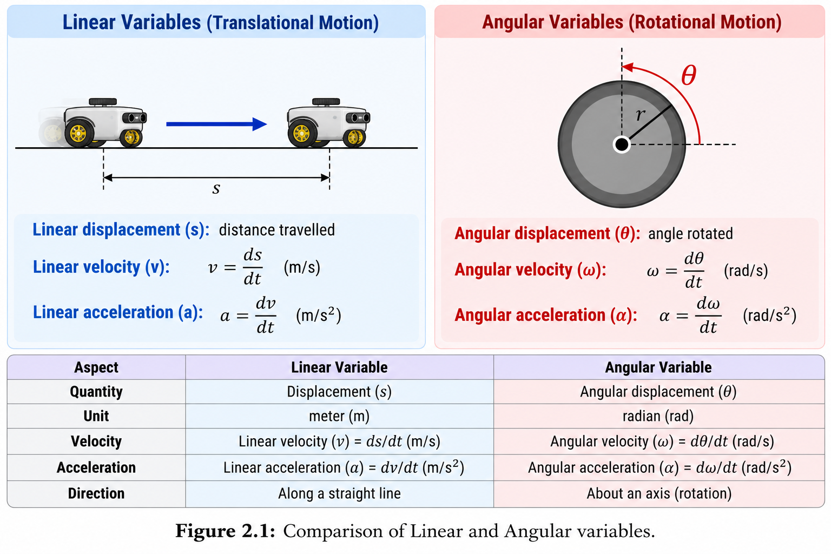
When a robot joint rotates with an angular velocity omega, the end of the robot link (at radius r) moves with a linear velocity v = r x omega.
2.2 Motion Profiles: Why Smoothness Matters
If you tell a robot motor to instantly jump from 0 rad/s to 10 rad/s, the required acceleration is infinite. In the real world, infinite acceleration requires infinite force (torque), which will strip the gears, break the shaft, or cause the robot to violently shake and fall over.
To prevent this, we use Motion Profiles. A motion profile dictates how a robot should accelerate, cruise, and decelerate between two points.
The Trapezoidal Velocity Profile
The most common motion profile in robotics is the Trapezoidal Profile. It consists of three phases:
- Acceleration Phase: The motor ramps up at a constant, safe acceleration ($a_{max}$).
- Cruise Phase: The motor runs at a constant maximum velocity ($v_{max}$).
- Deceleration Phase: The motor ramps down at a constant deceleration to stop exactly at the target position.

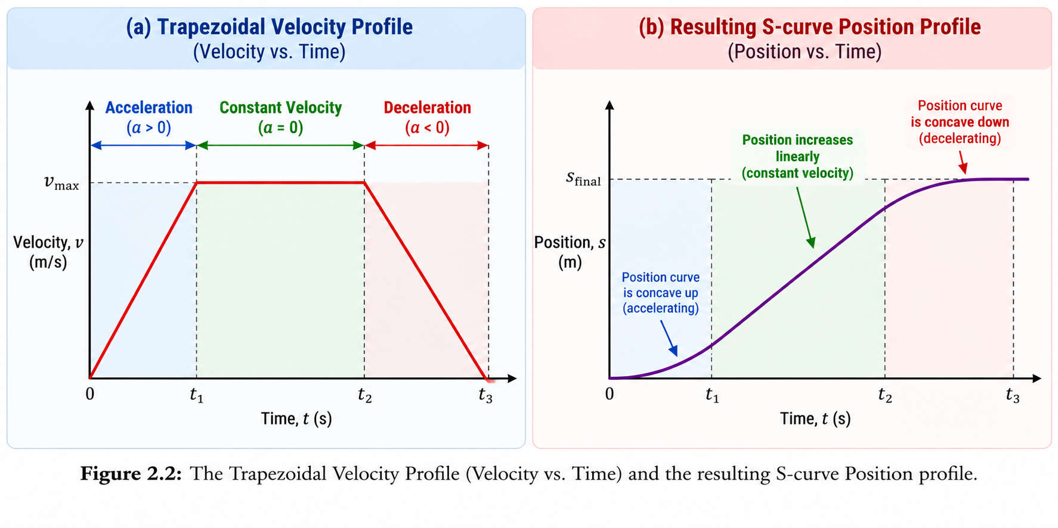
Mathematical Equations for Trapezoidal Profile
Let D be the total distance to travel, v_max be the max velocity, and a be the max acceleration.
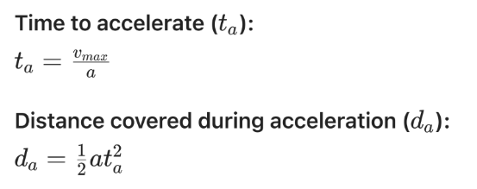
If 2 x da > D, the robot cannot reach v_max. It will only form a Triangular Profile (it accelerates and immediately decelerates).
2.3 Jerk: The Hidden Enemy
Jerk is the rate of change of acceleration (J = da/dt). In a trapezoidal profile, acceleration jumps instantly from 0 to a_max. This means a jerk is infinite at the start of the move. High jerks cause vibrations and wear on mechanical parts. Advanced robots use S-Curve Profiles, where acceleration itself is ramped smoothly, limiting jerks. This results in ultra-smooth motion, crucial for robots carrying liquids or delicate objects.
2.4 Common Mistakes to Avoid
- Ignoring Deceleration Distance: Calculating the time to reach max velocity but forgetting that the robot needs equal distance to stop. This causes the robot to overshoot the target.
- Using Degrees instead of Radians for Velocity: Angular velocity omega in physics and code is almost always in rad/s.
- Assuming all joints can move at the same speed: A large base joint requires much more torque to accelerate than a small wrist joint.

Lab Exercise 2: Generating and Plotting Motion Profiles
Objective To write a Python script that generates a trapezoidal velocity profile for a robot joint moving from 0 to 90 degrees, and plots the Position, Velocity, and Acceleration over time.
Software Required
- Python 3.x with numpy and matplotlib.
Working Principle We will define the kinematic limits (v_max, a_max) and calculate the time segments for acceleration, cruise, and deceleration. We will then generate arrays for time, velocity, and position to visualize the motion.
Procedure
- Define the target distance (e.g., pi/2 radians for 90 degrees).
- Set v_max = 2.0rad/s and a_max= 4.0 rad/s².
- Calculate the time segments.
- Use numpy to construct the velocity and position arrays.
- Plot the three profiles (Position, Velocity, Acceleration) in subplots.
Program Code
import numpy as np
import matplotlib.pyplot as plt
# Parameters
target_dist = np.pi / 2 # 90 degrees in radians
v_max = 2.0 # rad/s
a_max = 4.0 # rad/s²
# 1. Calculate times
t_a = v_max / a_max # Acceleration time
d_a = 0.5 * a_max * t_a**2 # Distance during accel
# Check if we can reach v_max (Triangular vs Trapezoidal)
if 2 * d_a > target_dist:
# Triangular profile
t_a = np.sqrt(target_dist / a_max)
v_max_actual = a_max * t_a
t_cruise = 0
t_d = t_a
else:
# Trapezoidal profile
v_max_actual = v_max
d_cruise = target_dist - 2 * d_a
t_cruise = d_cruise / v_max_actual
t_d = t_a
t_total = t_a + t_cruise + t_d
dt = 0.01
t = np.arange(0, t_total, dt)
# 2. Generate Velocity and Position arrays
v = np.zeros_like(t)
pos = np.zeros_like(t)
a = np.zeros_like(t)
for i, time in enumerate(t):
if time < t_a:
v[i] = a_max * time
a[i] = a_max
pos[i] = 0.5 * a_max * time**2
elif time < (t_a + t_cruise):
v[i] = v_max_actual
a[i] = 0
pos[i] = d_a + v_max_actual * (time - t_a)
else:
t_dec = time - (t_a + t_cruise)
v[i] = v_max_actual - a_max * t_dec
a[i] = -a_max
pos[i] = (d_a + d_cruise) + (v_max_actual * t_dec) - (0.5 * a_max * t_dec**2)
# 3. Plotting
fig, axs = plt.subplots(3, 1, sharex=True, figsize=(8, 10))
axs[0].plot(t, np.degrees(pos), 'g')
axs[0].set_ylabel('Position (deg)')
axs[0].grid(True)
axs[1].plot(t, np.degrees(v), 'b')
axs[1].set_ylabel('Velocity (deg/s)')
axs[1].grid(True)
axs[2].plot(t, np.degrees(a), 'r')
axs[2].set_ylabel('Acceleration (deg/s²)')
axs[2].set_xlabel('Time (s)')
axs[2].grid(True)
plt.suptitle('Trapezoidal Motion Profile for Robot Joint')
plt.show()
Expected Output Three stacked graphs. The position graph shows a smooth S-curve. The velocity graph shows a trapezoid. The acceleration graph shows a positive step, a zero line, and a negative step.

Observation
# | What to observe | Your observation
1 | Total time taken to complete the move
2 | Shape of the acceleration graph
3 | What happens to the profile if target_dist is very small?
Conclusion This activity proves that robot motion must be planned mathematically. By limiting acceleration, we ensure the robot moves smoothly and predictably, protecting its mechanical components.

3. Basic Kinematics
3.1 What is Kinematics?
Kinematics is the branch of mechanics that describes the motion of points and bodies without considering the forces that cause the motion. In robotics, kinematics is the mathematical mapping between the Joint Space (the angles of the motors) and the Cartesian Space (the X, Y, Z position of the robot's hand).
There are two main types of kinematics:
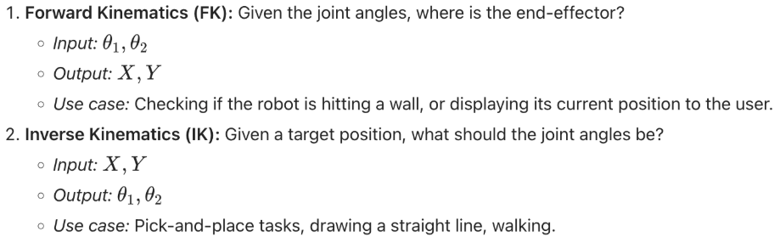
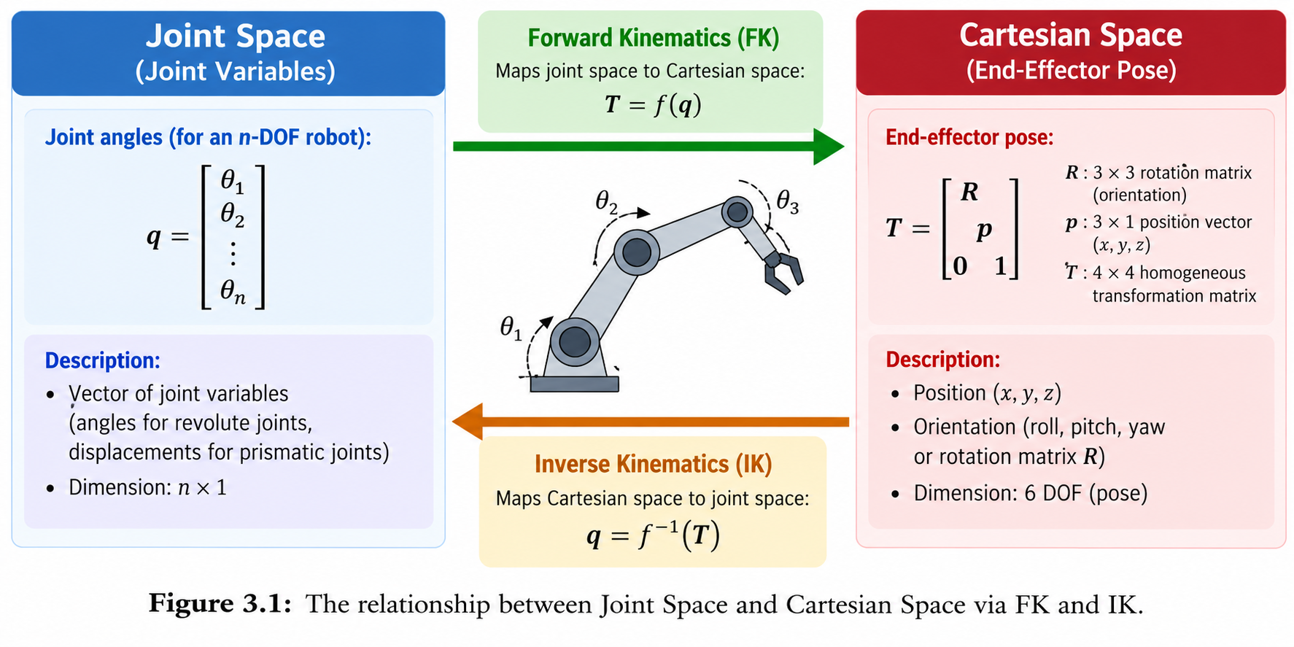

3.2 2D Forward Kinematics (Trigonometry Approach)
Let's look at a simple 2-DOF (Degree of Freedom) planar robot arm. It has two links:
- Link 1 length = L_1
- Link 2 length = L_2
- Joint 1 angle = theta_1(relative to the X-axis)
- Joint 2 angle = theta_2 (relative to Link 1)
To find the X, Y coordinates of the end-effector (the tip of Link 2), we use basic trigonometry.
The position of the end of Link 1 (the elbow) is:
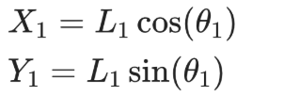
The position of the end of Link 2 is the elbow position plus the projection of Link 2. The absolute angle of Link 2 is 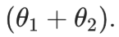
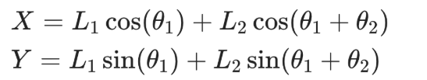
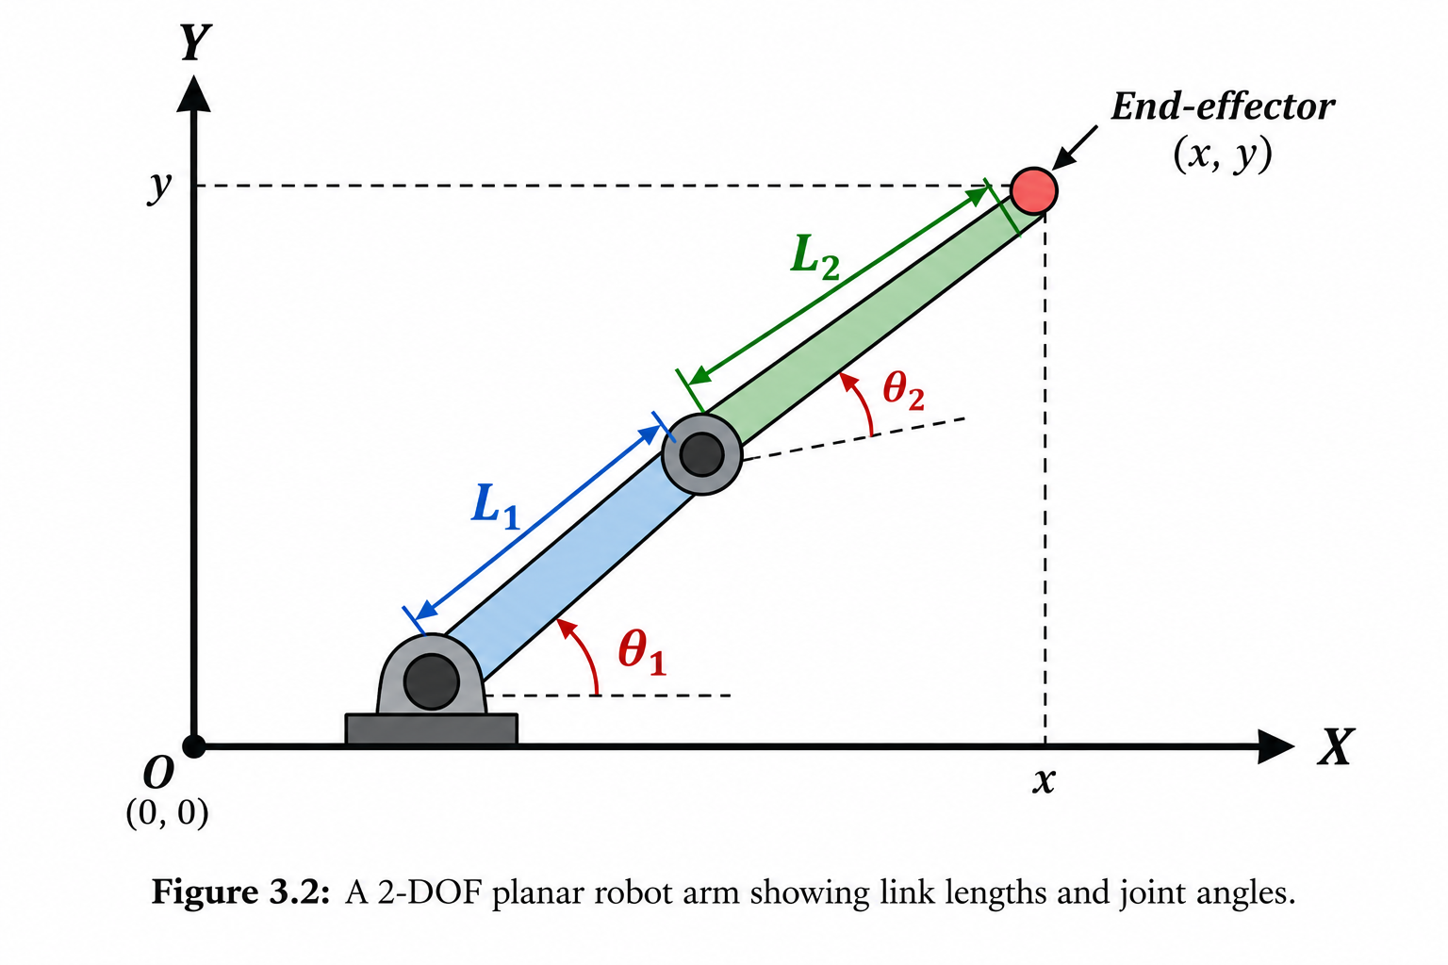
3.3 2D Inverse Kinematics (Geometric Approach)
Inverse kinematics is harder because there can be multiple solutions (e.g., "elbow up" vs "elbow down"), or no solution at all (if the target is too far away). 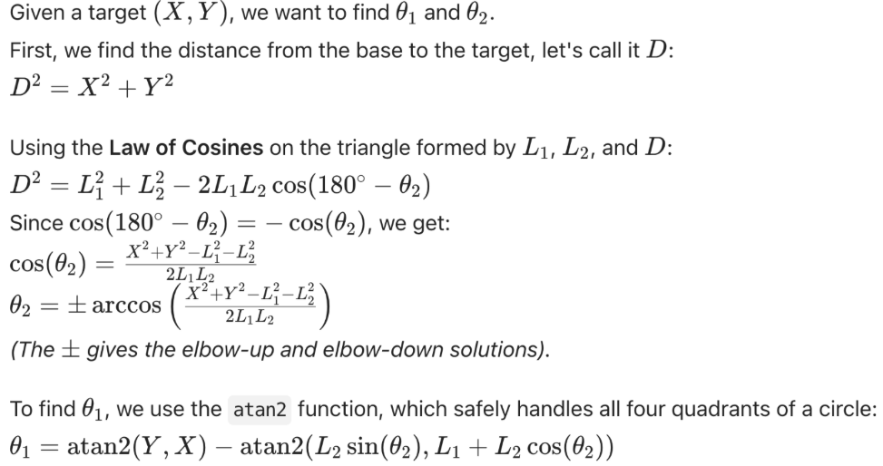
3.4 Introduction to Denavit-Hartenberg (DH) Parameters
For 3D robots with many joints, trigonometry becomes too messy. Engineers use a standardized method called Denavit-Hartenberg (DH) Parameters. DH assigns a coordinate frame to every single joint link. By multiplying Transformation Matrices (4x4 matrices that contain both rotation and translation) for each link, we get one master matrix that describes the exact pose of the end-effector.
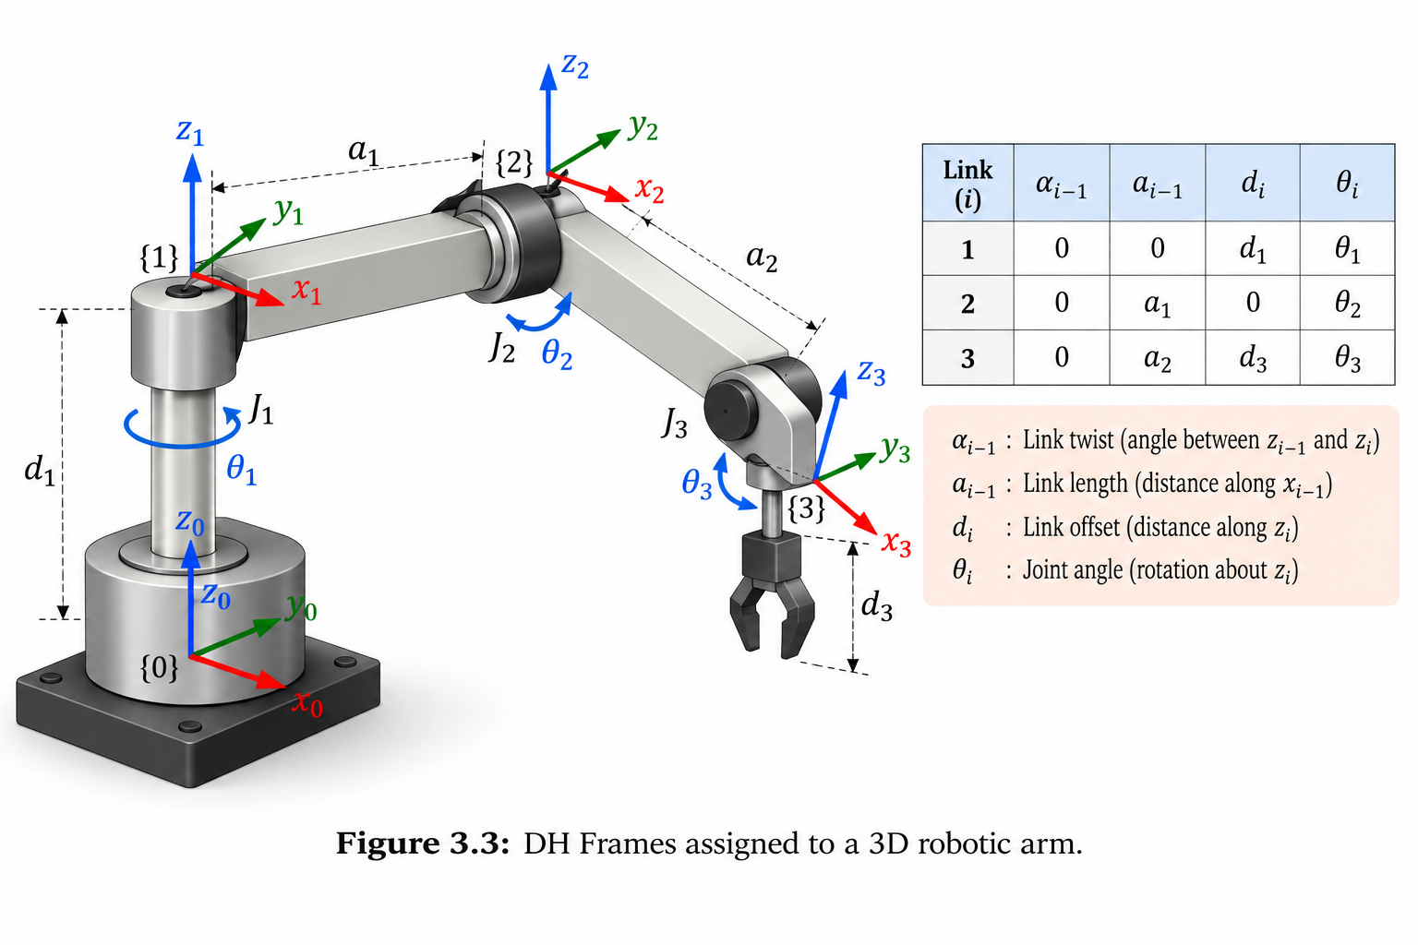
3.5 Common Mistakes to Avoid
- Confusing theta_2 relative to Link 1 vs. relative to the World: In FK equations, ensure you are using the absolute angle (theta_1 + theta_2) for the second link's projection.
- Ignoring the Workspace Boundary: Asking the IK solver to reach a point 2 meters away when the arm is only 1 meter long. The math will fail (domain error in arccos).
- Singularities: A singularity occurs when the robot arm is fully stretched out in a straight line. In this position, the robot loses a degree of freedom and IK solvers will behave erratically.
Lab Exercise 3: Forward and Inverse Kinematics of a 2-DOF Arm
Objective To write a Python program that calculates the Forward Kinematics (FK) and Inverse Kinematics (IK) of a 2-DOF robot arm, and visualizes the arm's reach.
Software Required
- Python 3.x with numpy and matplotlib.
Procedure
- Define link lengths L_1 = 1.0 m, L_2 = 1.0 m.
- Write a function fk(theta1, theta2) that returns X, Y.
- Write a function ik(x, y) that returns theta1, theta2.
- Plot the arm for a specific set of angles.
- Plot the "Workspace" (all reachable points) by looping through all possible angles.
Program Code
import numpy as np
import matplotlib.pyplot as plt
L1 = 1.0
L2 = 1.0
def fk(t1, t2):
x = L1 * np.cos(t1) + L2 * np.cos(t1 + t2)
y = L1 * np.sin(t1) + L2 * np.sin(t1 + t2)
return x, y
def ik(x, y):
D_sq = x**2 + y**2
cos_t2 = (D_sq - L1**2 - L2**2) / (2 * L1 * L2)
# Clamp to [-1, 1] to avoid math domain errors
cos_t2 = np.clip(cos_t2, -1.0, 1.0)
t2 = np.arccos(cos_t2) # Elbow up solution
k1 = L1 + L2 * np.cos(t2)
k2 = L2 * np.sin(t2)
t1 = np.arctan2(y, x) - np.arctan2(k2, k1)
return t1, t2
# 1. Test FK
t1_test, t2_test = np.pi/4, np.pi/3
x_fk, y_fk = fk(t1_test, t2_test)
print(f"FK Result: X={x_fk:.2f}, Y={y_fk:.2f}")
# 2. Test IK
x_target, y_target = 1.0, 1.0
t1_ik, t2_ik = ik(x_target, y_target)
print(f"IK Result: t1={np.degrees(t1_ik):.2f} deg, t2={np.degrees(t2_ik):.2f} deg")
# 3. Plot Workspace
fig, ax = plt.subplots(subplot_kw={'projection': 'polar'}) # Polar plot is great for arms
t1_range = np.linspace(0, 2*np.pi, 100)
t2_range = np.linspace(-np.pi, np.pi, 100)
T1, T2 = np.meshgrid(t1_range, t2_range)
X, Y = fk(T1, T2)
R = np.sqrt(X**2 + Y**2)
ax.scatter(T1, R, s=1, c=T2, cmap='hsv')
ax.set_title("Robot Arm Workspace (Reach)")
plt.show()
Observation
# | What to observe | Your observation
1 | Does the IK result match the FK input when tested in reverse?
2 | What shape is the workspace of a 2-DOF arm?
3 | What happens if you ask IK for X=3.0, Y=0.0?
Conclusion This activity demonstrates the mathematical bridge between joint space and Cartesian space. Forward kinematics is always unique and easy to calculate, while inverse kinematics requires careful handling of geometry and multiple solutions.
4. Robot Mechanisms and Actuators
4.1 Links, Joints, and Degrees of Freedom (DOF)
A robot is essentially a chain of rigid bodies connected by joints.
- Links: The rigid structural parts (usually made of aluminum, carbon fiber, or steel). They do not bend.
- Joints: The movable connections between links.
- Revolute Joint: Rotational (like a human elbow). Provides 1 DOF.
- Prismatic Joint: Linear/Sliding (like a telescoping antenna). Provides 1 DOF.
Degrees of Freedom (DOF): The number of independent parameters required to define the position of a mechanical system. A robot arm needs at least 6 DOF (3 for position, 3 for orientation) to reach any point in 3D space in any orientation.
4.2 Gears and Mechanical Advantage
Motors (actuators) spin very fast but produce very little torque (turning force). To move a heavy robot arm, we need to trade speed for force. This is done using gear.
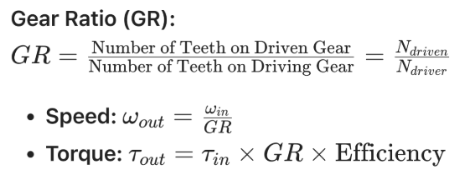
If a motor spins at 1000 RPM with 1 Nm of torque, and we attach a 10:1 gear reduction, the output shaft will spin at 100 RPM, but with roughly 10 Nm of torque. This is essential for robot joints.
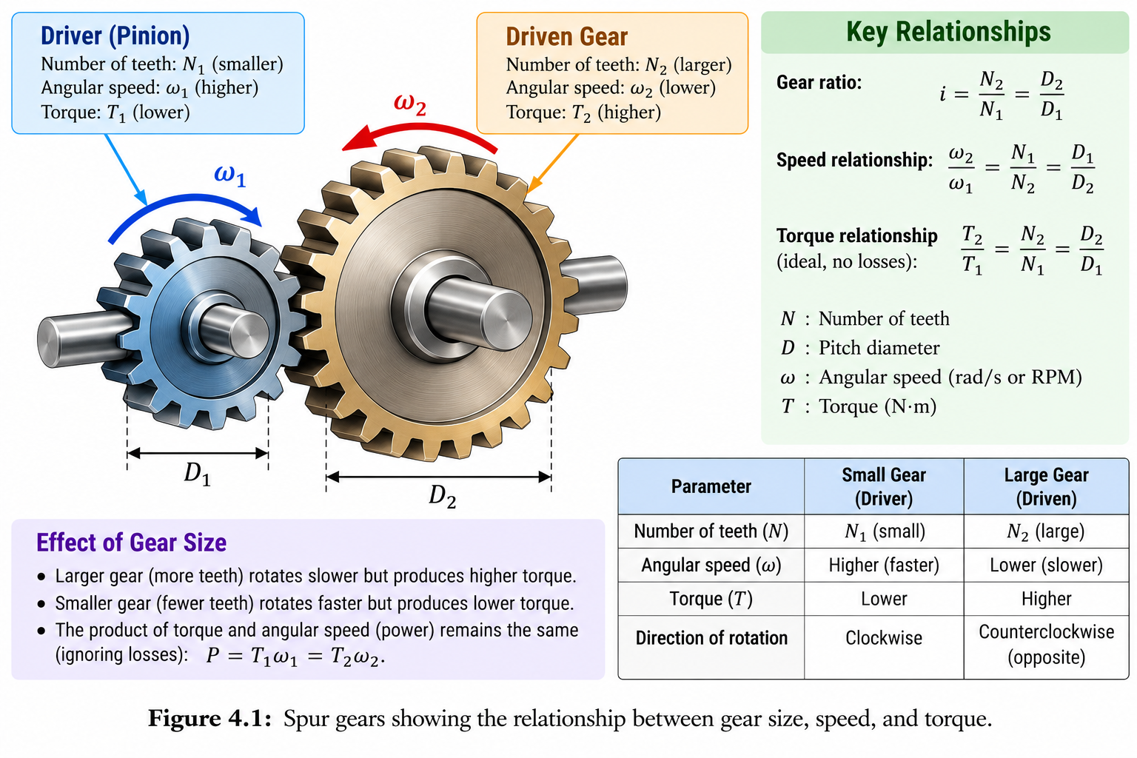
4.3 Harmonic Drives and Strain Wave Gears
Standard spur gears have "backlash" (a slight play or gap between teeth). In robotics, backlash is unacceptable because it causes the robot arm to wobble when it changes direction. Robots use Harmonic Drives (Strain Wave Gears). These use a flexible spline that deforms to mesh with a circular spline. They provide massive gear reductions (e.g., 100:1) in a single, compact package with zero backlash.
4.4 Mobile Robot Mechanisms: The Differential Drive
Not all robots have arms; many are mobile bases. The most common mechanism for indoor robots (like Roomba or warehouse AGVs) is the Differential Drive.
A differential drive has two independently driven wheels on a common axis, plus a caster wheel for balance.
- If both wheels spin forward at the same speed (v_L = v_R), the robot moves in a straight line.
- If the wheels spin at different speeds, the robot turns.
- If the wheels spin in opposite directions (v_L = -v_R), the robot spins in place.
Differential Drive Kinematics: Let R be the wheel radius, L be the distance between the wheels, and omega_L, omega_R be the angular velocities of the left and right wheels.
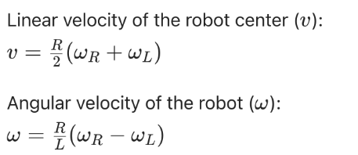
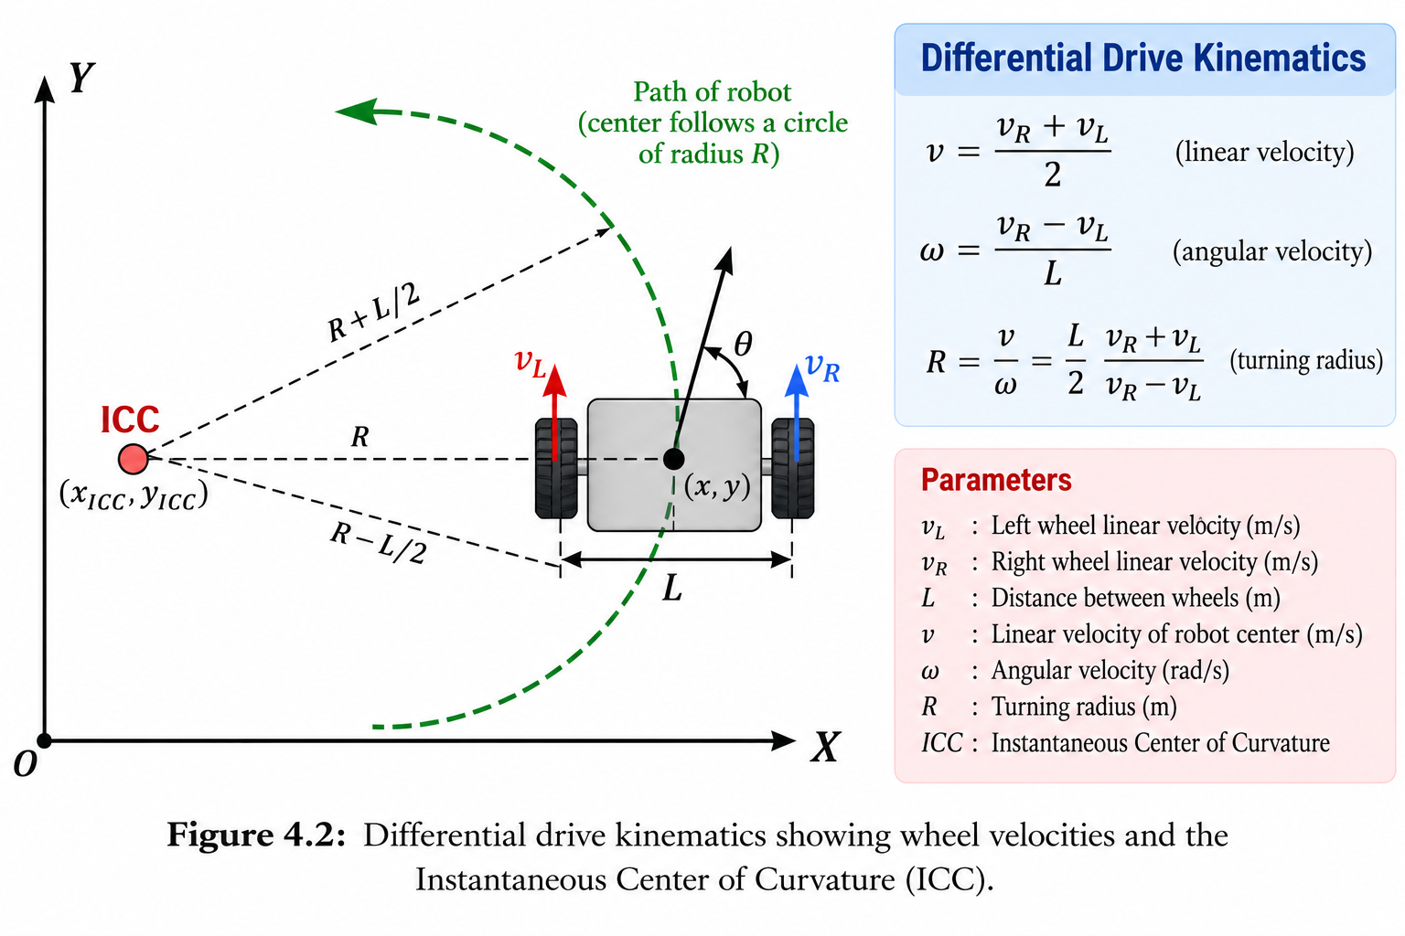

4.5 Common Mistakes to Avoid
- Ignoring Backlash in CAD: Designing a robot arm with cheap 3D-printed gears will result in a sloppy, inaccurate robot. Always specify zero-backlash mechanisms for joints.
- Overloading the Motor: Gears multiply torque, but they also multiply the reflected inertia. If the robot arm hits a wall, the shock is multiplied back into the motor, potentially stripping the gears.
- Assuming Differential Drive can move sideways: A standard differential drive cannot move laterally (strafe). It is non-holonomic. For omnidirectional movement, you need Mecanum or Omni wheels.

Lab Exercise 4: Analyzing a Differential Drive Mechanism
Objective To calculate the required wheel speeds for a differential drive robot to follow a specific curved path and simulate its trajectory using Python.
Software Required
- Python 3.x with numpy and matplotlib.
Procedure
- Define robot parameters: Wheel radius R = 0.05 m, Wheelbase L = 0.3 m.
- Set a constant linear velocity v = 0.2 m/s and angular velocity omega = 0.5 rad/s.
- Calculate the required omega_L and omega_R.
- Simulate the robot's X, Y, and theta over 10 seconds using a simple Euler integration loop.
- Plot the resulting path.
Program Code
import numpy as np
import matplotlib.pyplot as plt
# Robot Parameters
R = 0.05 # Wheel radius (m)
L = 0.3 # Distance between wheels (m)
# Desired Motion
v = 0.2 # Linear velocity (m/s)
w = 0.5 # Angular velocity (rad/s)
# 1. Calculate Wheel Speeds (rad/s)
w_R = (v / R) + (w * L / (2 * R))
w_L = (v / R) - (w * L / (2 * R))
print(f"Right Wheel Speed: {w_R:.2f} rad/s")
print(f"Left Wheel Speed: {w_L:.2f} rad/s")
# 2. Simulate Trajectory
dt = 0.1 # Time step
time = np.arange(0, 10, dt)
x, y, theta = 0.0, 0.0, 0.0
path_x, path_y = [x], [y]
for t in time:
# Update pose
x += v * np.cos(theta) * dt
y += v * np.sin(theta) * dt
theta += w * dt
path_x.append(x)
path_y.append(y)
# 3. Plot
plt.figure(figsize=(8, 8))
plt.plot(path_x, path_y, 'b-', label='Robot Path')
plt.plot(0, 0, 'ro', label='Start')
plt.plot(path_x[-1], path_y[-1], 'g*', label='End')
plt.grid(True)
plt.axis('equal')
plt.xlabel('X (m)')
plt.ylabel('Y (m)')
plt.title('Differential Drive Trajectory (Constant v and w)')
plt.legend()
plt.show()
Observation
# | What to observe | Your observation
1 | Shape of the trajectory when w is constant
2 | Wheel speeds if the robot needs to spin in place (v=0)
3 | Effect of increasing dt on the simulation accuracy
Conclusion This activity demonstrates how mobile robot kinematics translate simple wheel rotations into complex 2D paths. It forms the basis for all mobile robot navigation and path-planning algorithms.

5. Module Project: 2-DOF Robot Arm Simulator
5.1 Problem Statement
You are tasked with creating a software simulation of a 2-DOF planar robot arm. The simulator must accept a target (X, Y) coordinate, calculate the Inverse Kinematics to find the joint angles, generate a smooth trapezoidal motion profile to move the joints from their current position to the target, and animate the arm's movement over time.
5.2 System Architecture
The project is divided into three logical blocks:
- Kinematics Engine: Handles the FK and IK math.
- Trajectory Planner: Generates the trapezoidal velocity profiles for Joint 1 and Joint 2.
- Visualizer: Uses matplotlib.animation to draw the arm moving in real-time.
5.3 Implementation Steps
- Initialize: Define link lengths and starting joint angles.
- Target Input: Prompt the user for an X, Y coordinate.
- IK Calculation: Compute the target angles theta_1target and theta_2 target.
- Profile Generation: Calculate the time required for each joint to move, ensuring they arrive at the target at the exact same time (synchronized motion).
- Animation Loop: Step through time, updating the joint angles based on the motion profile, and redraw the arm.
Lab Exercise 5: Integration and Testing
Objective To combine the concepts of Kinematics and Motion Profiles into a single, animated Python simulation.
Software Required
- Python 3.x with numpy, matplotlib, and matplotlib.animation.
Procedure
- Copy the FK and IK functions from Lab 3.
- Copy the Trapezoidal Profile logic from Lab 2.
- Write an animation loop that updates the joint angles frame-by-frame.
- Test the simulator with multiple targets, including targets near the workspace boundary.
Program Code (Animation Snippet)
import matplotlib.animation as animation
# ... [Insert FK, IK, and Profile functions here] ...
fig, ax = plt.subplots()
ax.set_xlim(-2.5, 2.5)
ax.set_ylim(-2.5, 2.5)
ax.set_aspect('equal')
ax.grid(True)
line, = ax.plot([], [], 'o-', lw=3, color='blue')
target_dot, = ax.plot([], [], 'r*', markersize=15)
def init():
line.set_data([], [])
target_dot.set_data([], [])
return line, target_dot
# Target and Profile Setup
x_target, y_target = 1.2, 0.8
t1_target, t2_target = ik(x_target, y_target)
t1_current, t2_current = 0.0, 0.0 # Assume starting at 0,0
# Generate time profiles for both joints (simplified for animation)
frames = np.linspace(0, 2*np.pi, 100)
t1_profile = np.linspace(t1_current, t1_target, len(frames))
t2_profile = np.linspace(t2_current, t2_target, len(frames))
def animate(i):
t1 = t1_profile[i]
t2 = t2_profile[i]
# FK to get link positions
x1 = L1 * np.cos(t1)
y1 = L1 * np.sin(t1)
x2 = x1 + L2 * np.cos(t1 + t2)
y2 = y1 + L2 * np.sin(t1 + t2)
line.set_data([0, x1, x2], [0, y1, y2])
target_dot.set_data([x_target], [y_target])
return line, target_dot
ani = animation.FuncAnimation(fig, animate, frames=len(frames), init_func=init, blit=True, interval=50)
plt.title("2-DOF Robot Arm Simulation")
plt.show()
Expected Output An animated window showing a blue line (the robot arm) smoothly rotating from its home position to reach a red star (the target coordinate).
Observation
# | What to observe | Your observation
1 | Does the arm reach the exact center of the red star?
2 | Is the motion smooth, or does it jerk?
3 | What happens if you input a target outside the arm's reach?
Outcome: The learner produces a working, animated robotic simulator that proves their understanding of how mathematical kinematics and motion planning combine to create realistic robot behavior.

Review Questions
- Explain the difference between Position and Pose. Why is orientation critical in robotic pick-and-place tasks?
- Using the Right-Hand Rule, describe the positive direction of rotation around the Y-axis.
- Why do we use Trapezoidal or S-Curve motion profiles instead of simply telling a motor to "go to position X"?
- Calculate the linear velocity of the end of a 0.5-meter robot link if the joint is rotating at 2 rad/s.
- What is the difference between Forward Kinematics and Inverse Kinematics? Which one is computationally harder to solve, and why?
- In a 2-DOF planar arm, what happens mathematically when you ask the IK solver to reach a point exactly at $L_{1}+L_{2}$? What is this state called?
- A motor spins at 1000 RPM with 0.5 Nm of torque. It is connected to a 20:1 gear reduction. What are the output speed and torque (assuming 100% efficiency)?
- Why are Harmonic Drives preferred over standard spur gears in high-precision robot joints?
- Write the kinematic equations for the linear velocity ($v$) and angular velocity ($ω$) of a differential drive robot.
- If a differential drive robot has $v_L = v_R$, what is its angular velocity, and what shape is its trajectory?
- What is "backlash", and how does it affect a robot arm's accuracy?
- Explain the concept of a "Singularity" in robotics. Why must trajectory planners avoid them?

